OwnCloud Installation

**Aim -** To implement Cloud as Storage as a Service(SaaS) by installing OwnCloud on Ubuntu VM.

**Theory -**

Owncloud - It is a suite of [client–server software](https://en.wikipedia.org/wiki/Client%E2%80%93server_model) for creating and using [file hosting services](https://en.wikipedia.org/wiki/File_hosting_service). OwnCloud functionally has similarities to the widely used [Dropbox](https://en.wikipedia.org/wiki/Dropbox_(service)). The primary functional difference between ownCloud and Dropbox is that ownCloud does not offer data centre capacity to host stored files. The Server Edition of ownCloud is [free and open-source](https://en.wikipedia.org/wiki/Free_and_open-source), thereby allowing anyone to install and operate it without charge on their own [private server](https://en.wikipedia.org/wiki/Private_server).

ownCloud supports extensions that allow it to work like [Google Drive](https://en.wikipedia.org/wiki/Google_Drive), with online document editing, calendar and contact synchronization, and more. Its openness avoids enforced [quotas](https://en.wikipedia.org/wiki/Disk_quota) on storage space or the number of connected clients, instead of having hard limits (for example on storage space or number of users) limits are determined by the physical capabilities of the server.

**Installation -**

**INSTALLING LAMP(APACHE 2, PHP7, MARIADB) ON UBUNTU 20.10**

Step1: Install Apache on system

1.1 install apache2

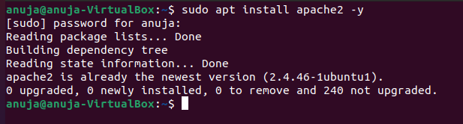

1.2 check status apache

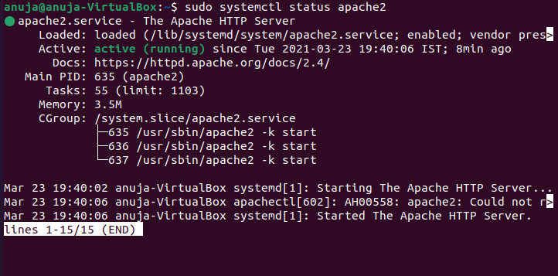

1.3 enable auto start at boot time

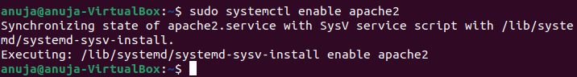

1.4 config firewall to allow Apache web server

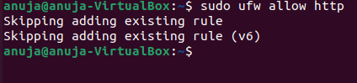

1.5 enable system startup

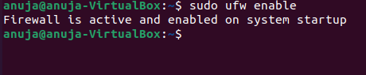

1.6 check status. It is allowed on port 80.

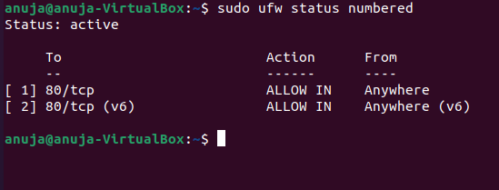

1.7 run ifconfig to know the IP addresses



1.8 install package for using various commands and tools

If getting error as follows then use command - kill -9 *process id*

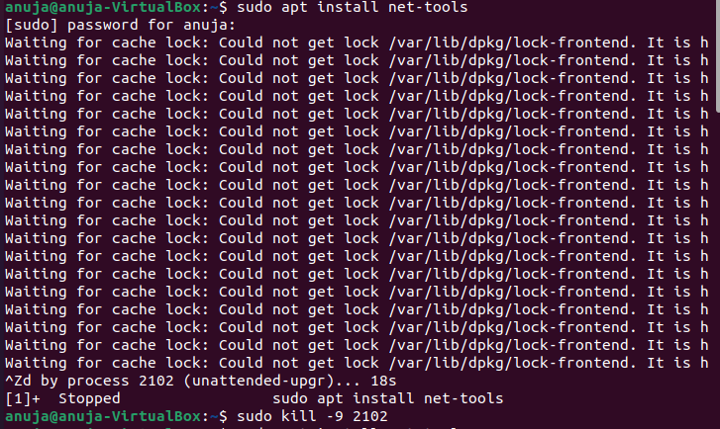

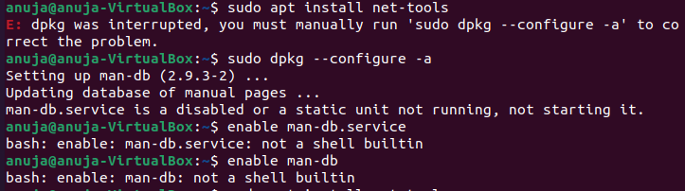

1.9 finally installed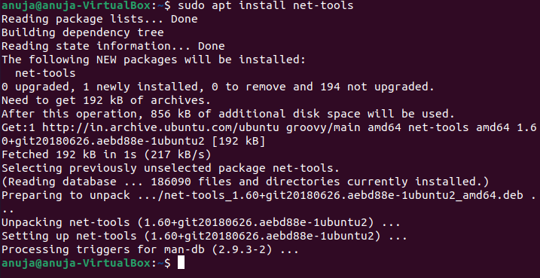

1.10 run ifconfig command

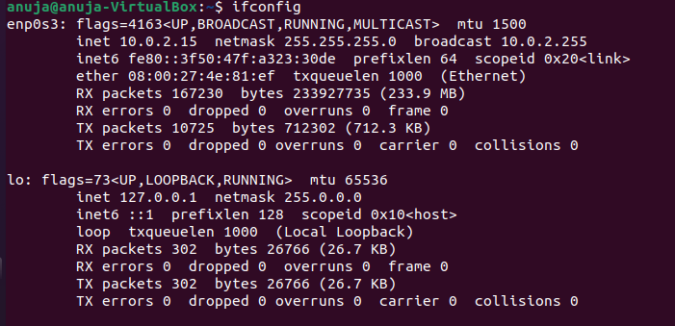

Here my IP is 10.0.2.15

1.11 Now test

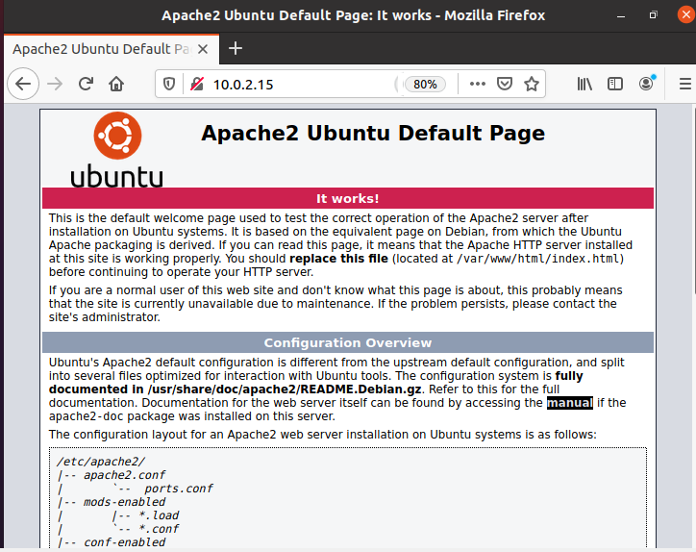

It’s working!

Step 2: Install PHP 7 on system

2.1 install PHP and PHP modules

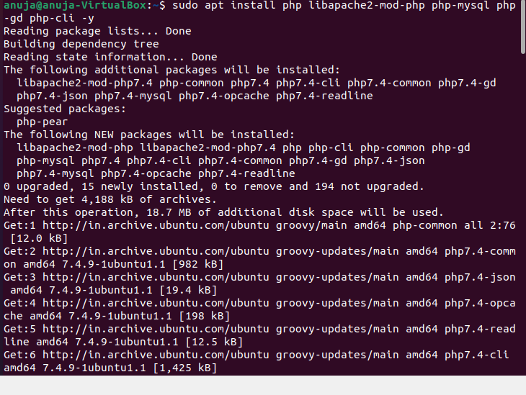

2.2 PHP 7 installed

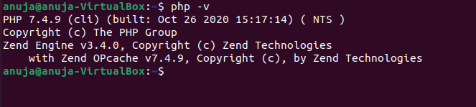

2.3 install vim

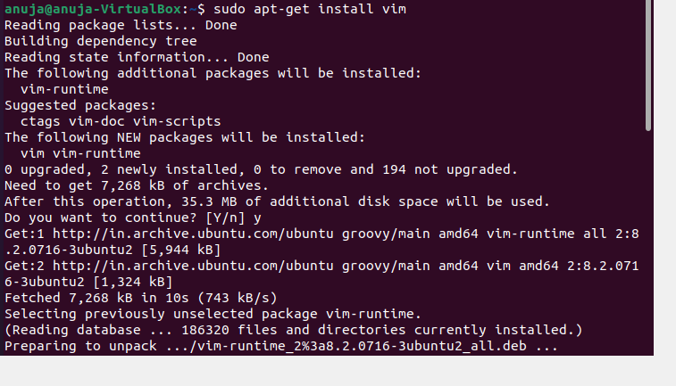

2.4 test PHP

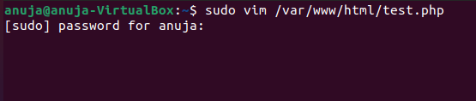

Press qa for changing into insert mode

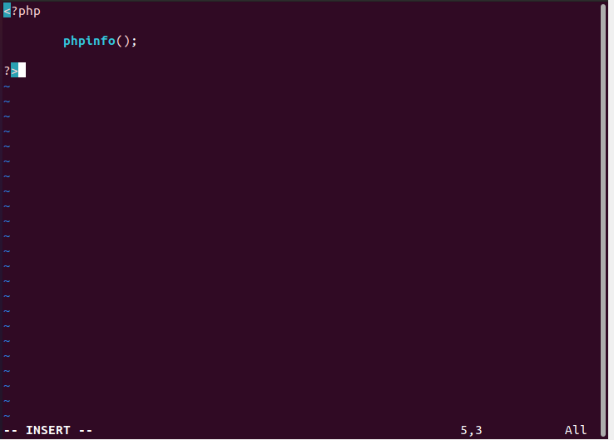

Press esc -> : -> x-> enter to save file

2.5 restart Apache

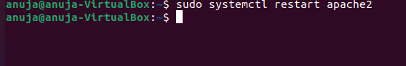

2.6 On browser check if PHP is working

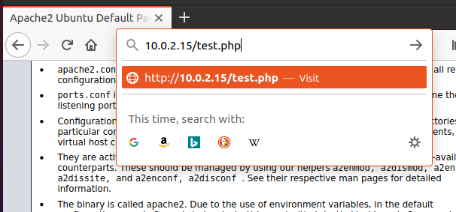

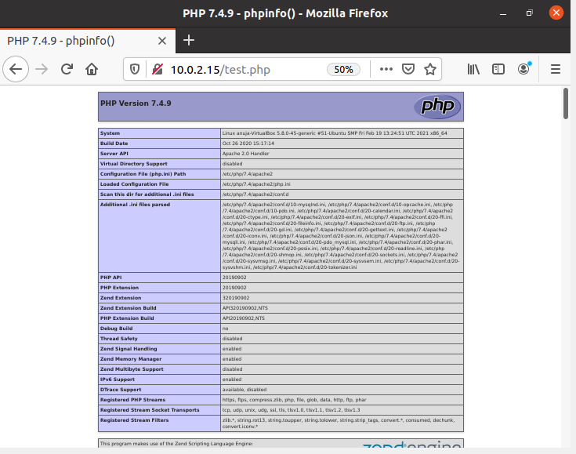

It’s working!

Step 3: Install MariaDB 10 on system

3.1 install MariaDB

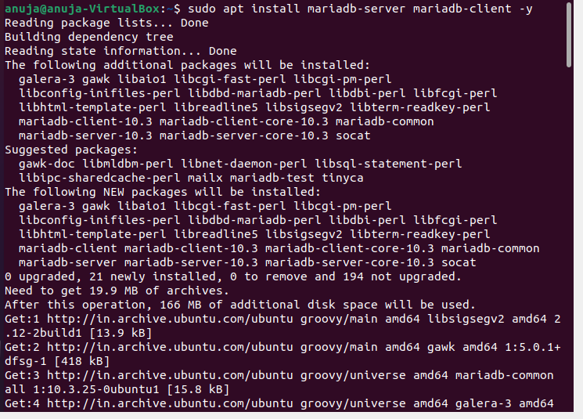

3.2 check status MariaDB

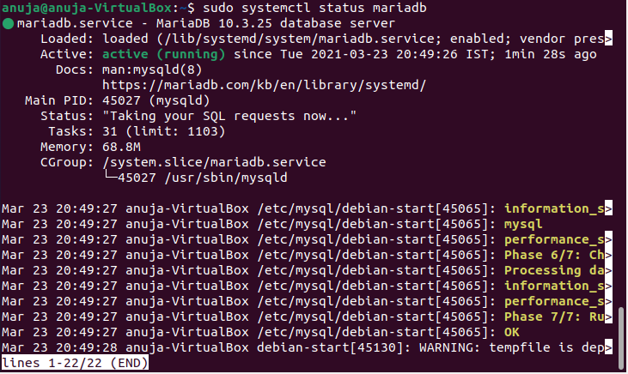

3.3 enable auto start at boot time & secure MariaDB

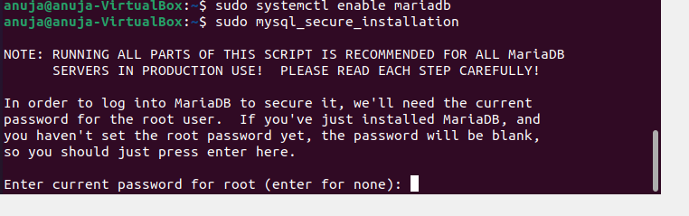

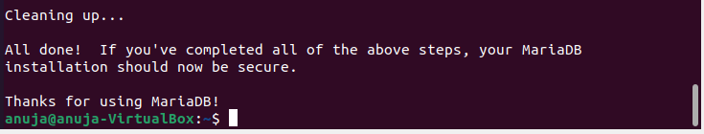

3.4 login MariaDB

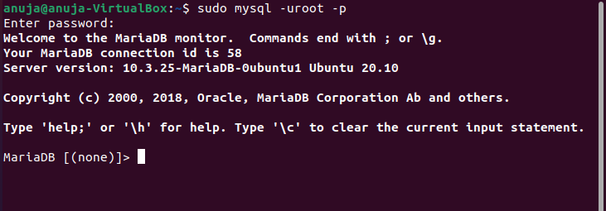

**INSTALLING OWNCLOUD LATEST VERSION ON UBUNTU 20.10**

Step 1: Check requirements

1.1 update the system

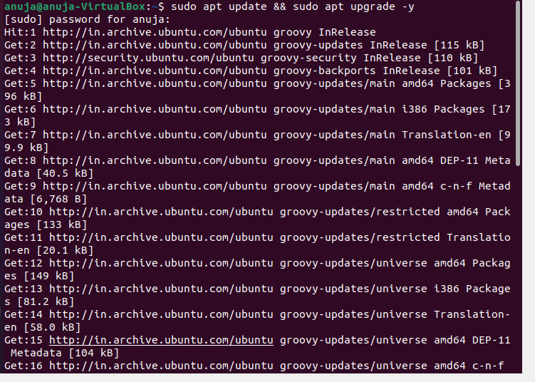

1.2 ensure Apache, MariaDB/ MySQL, PHP installed on the system

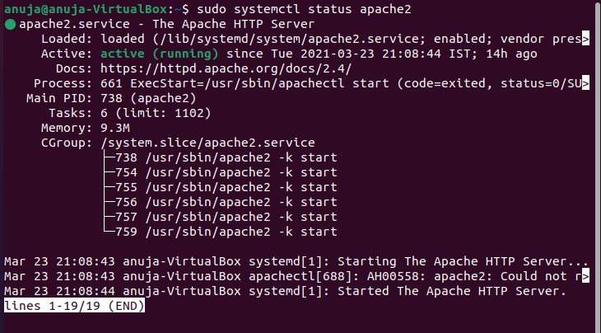

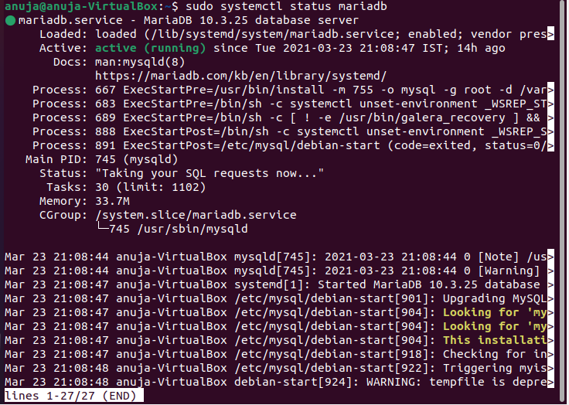

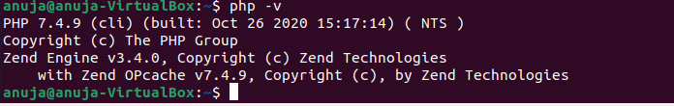

1.3 install PHP modules required by ownCloud

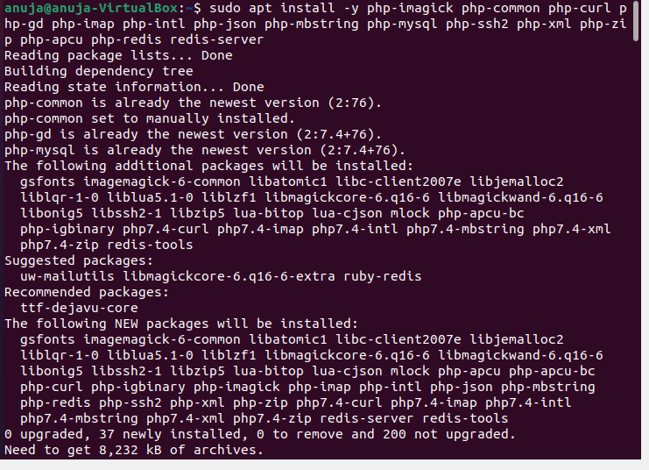

Step 2: create a new Database for ownCloud

2.1 Login MariaDB

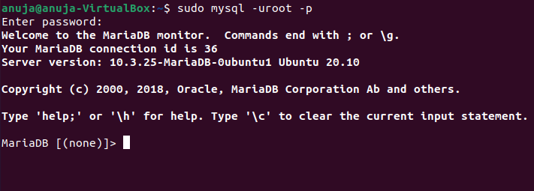

2.2 create a new database named “ownclouddb”

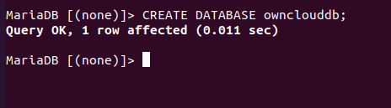

2.3 create a new database user called “ownclouduser” with pswd “owncloudpswd”

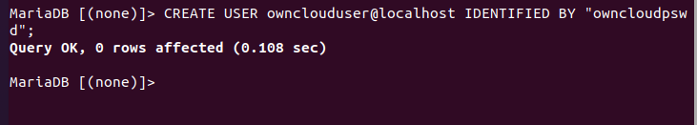

2.4 grant all the rights of “ownclouddb” to “ownclouduser”

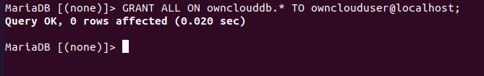

2.5 reload & exit

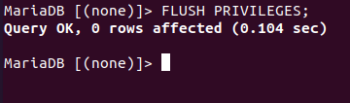

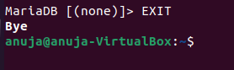

Step 3: download ownCloud latest version

3.1 move to /var/www directory

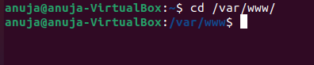

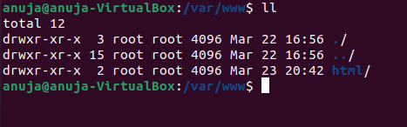

3.2 get the link to download ownCloud on browser

<https://owncloud.com/download-server/>

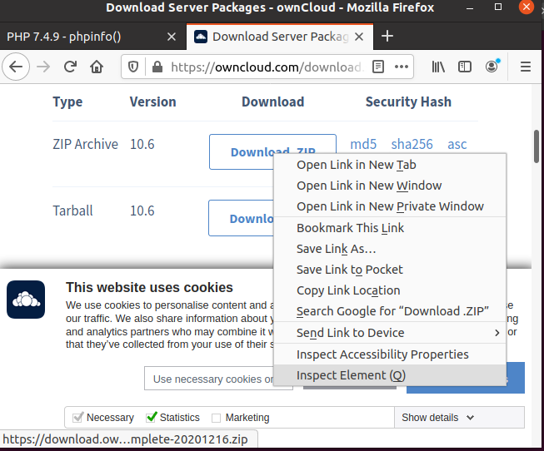

right click on download zip and select copy link location

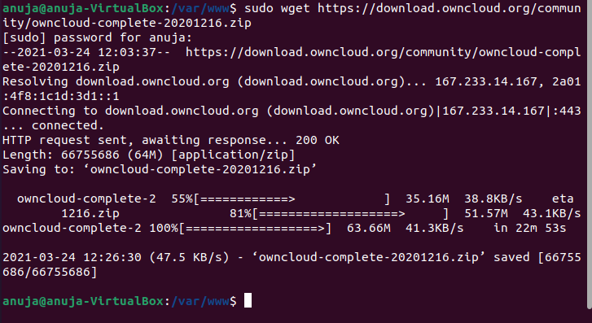

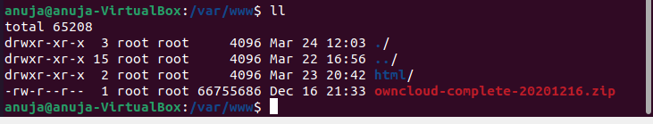

Step 4: Configure OwnCloud

4.1 extract the zip file you downloaded

sudo unzip owncloud-20201216.zip

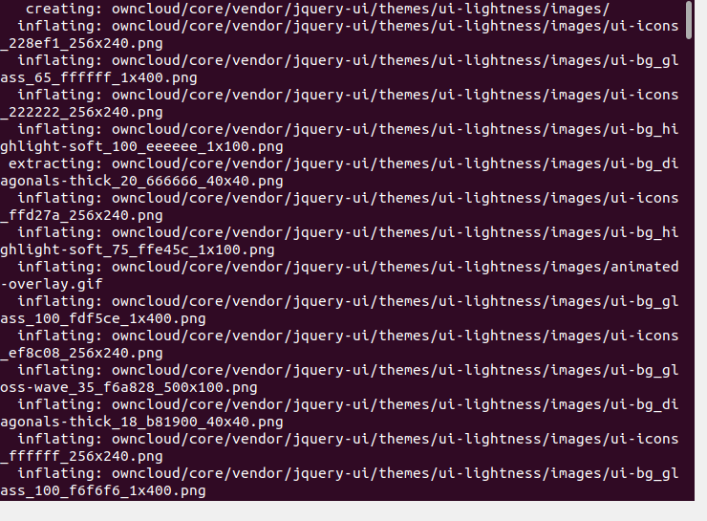

Extracted

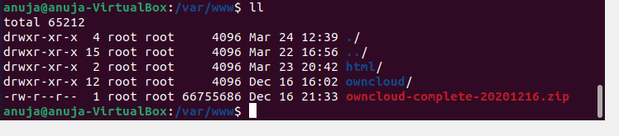

4.2 change permissions on ownCloud directory



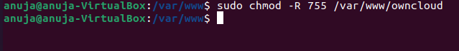

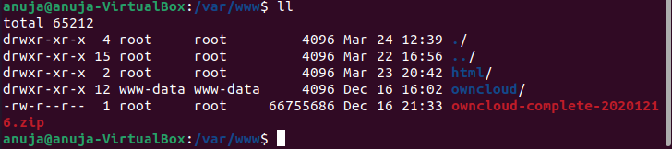

4.3 create a virtual host configuration for ownCloud



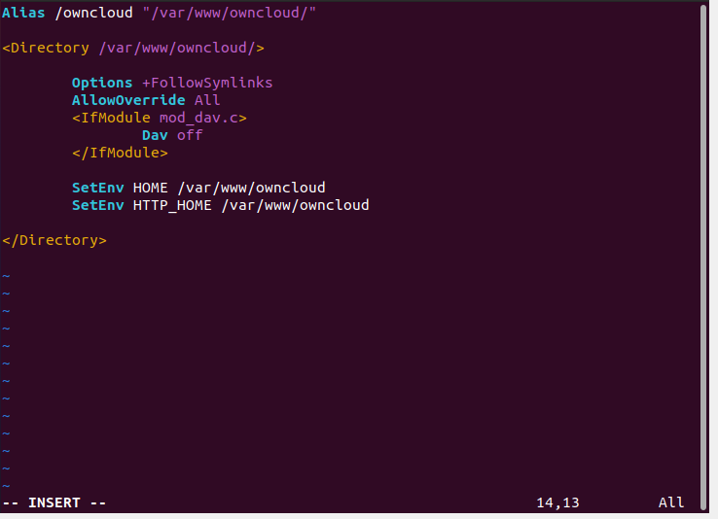

Save file esc -> : -> x -> enter

4.4 enable all the required Apache modules

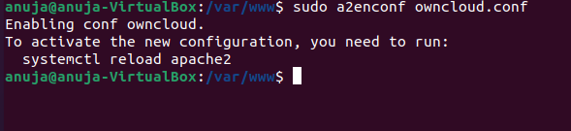

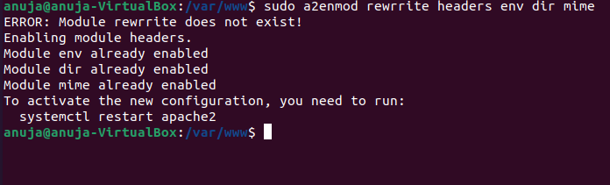

Step 5: Setup OwnCloud

5.1 restart Apache, MariaDB services

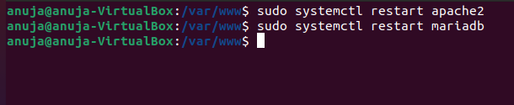

5.2 on browser access address <http://localhost/owncloud>

Create a new admin username & password

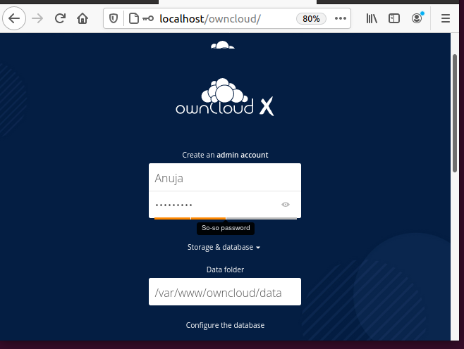

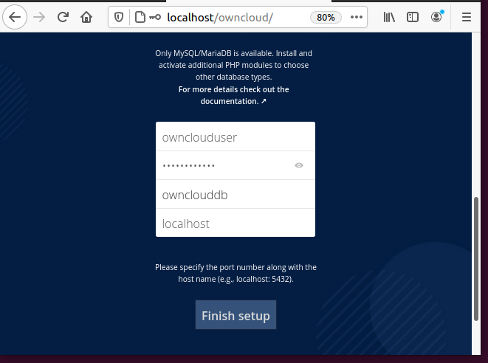

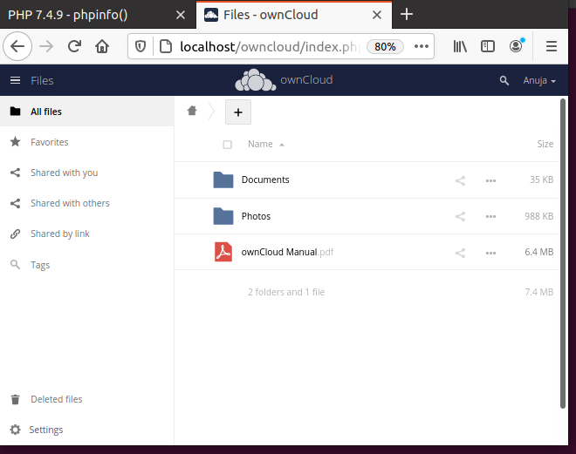

Now you can store the files on owncloud.

I created a docx file and uploaded it on ownCloud.

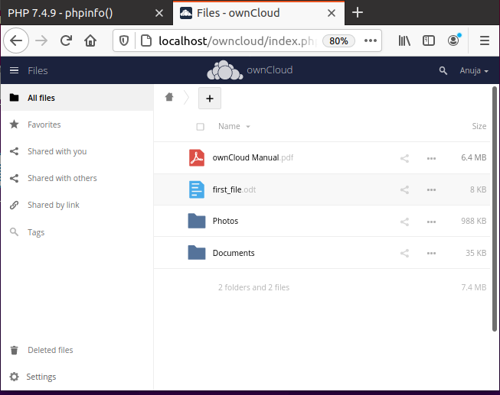

**Conclusion -** Thus, we have successfully installed Owncloud and used it as a storage service.